Exploratory Data Analysis of E-Commerce Dataset
To analyse sales data and identify trends, patterns, and outliers.
Basic Statistics:
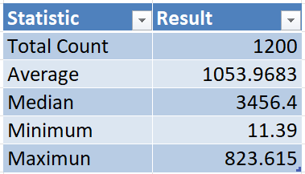
Chart representation:
Product analysis:
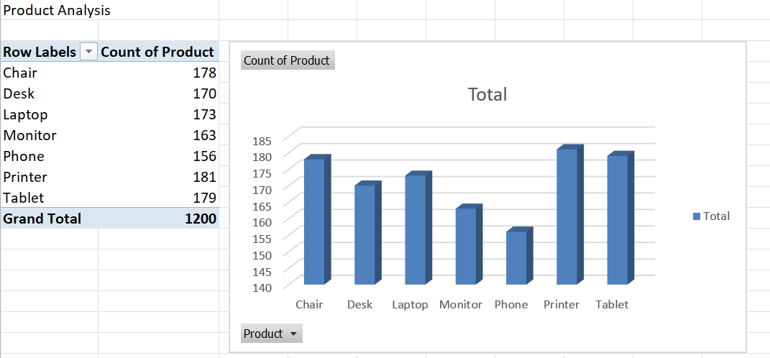
Payment method analysis:
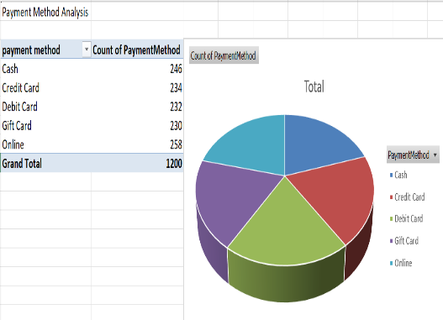
Order status analysis:
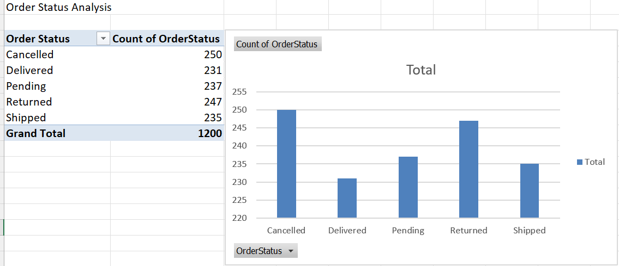
Year-wise sales analysis:
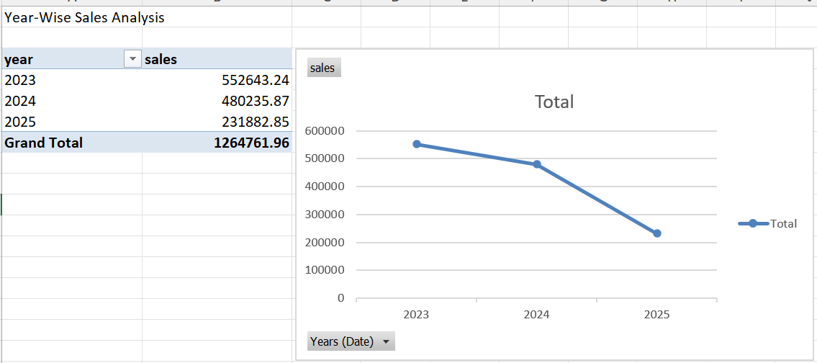
Referral source analysis:
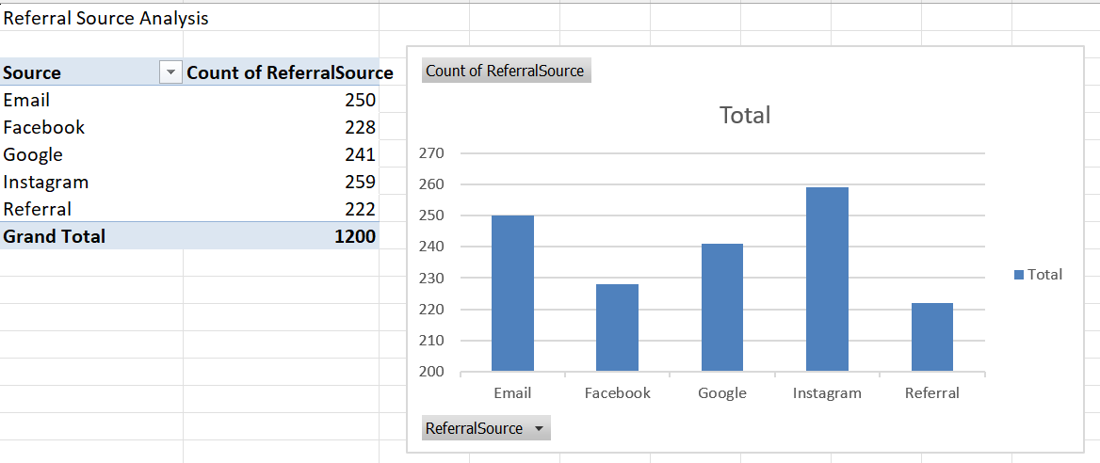
Coupon analysis:
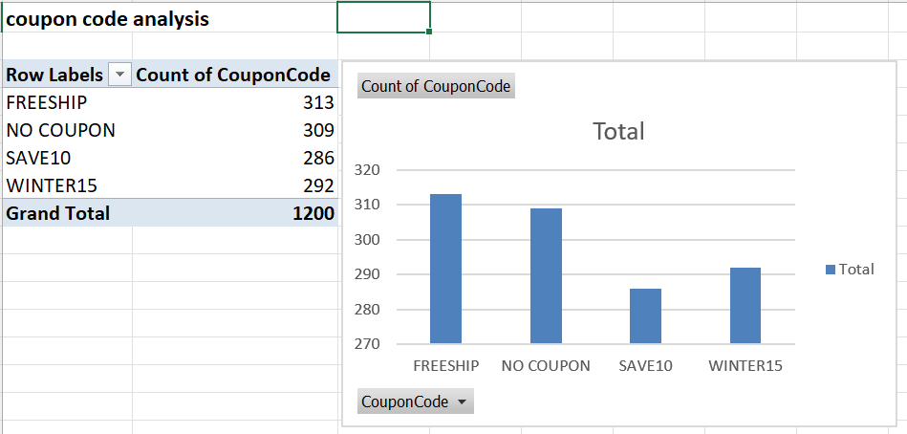
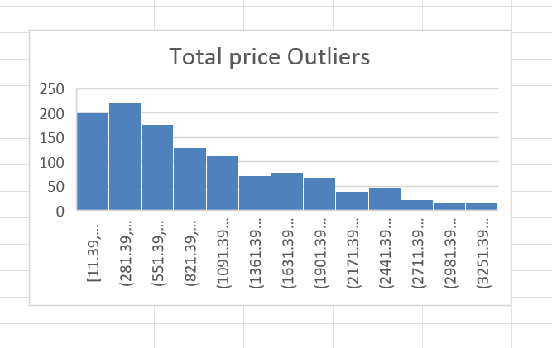
Key Findings
- The dataset contains 1200 customer orders, providing sufficient data for analysis.
- The average order value is approximately ₹1053.97, indicating the typical amount spent per order.
- Printer is the most frequently ordered product, showing high customer demand.
- Online Payment is the most preferred payment method among customers.
- A significant number of orders are marked as Cancelled, indicating potential issues in the order fulfillment process.
- Sales revenue was highest in 2023 and showed a declining trend in subsequent years.
- Some orders have exceptionally high TotalPrice values and can be considered outliers.
- Customers use coupons regularly, but certain coupon codes are significantly more popular than others.
- Referral sources contribute differently to customer acquisition, with some channels generating more orders than others.
- The dataset reveals clear purchasing patterns that can help businesses improve marketing strategies, sales performance, and customer satisfaction.
Conclusion
The Exploratory Data Analysis (EDA) helped identify customer purchasing behavior, product demand, payment preferences, sales trends, and outliers. These insights can support better business decisions and improve overall performance.

